Printing board Layout Eagle

Change background to White

**Options-User Interface**

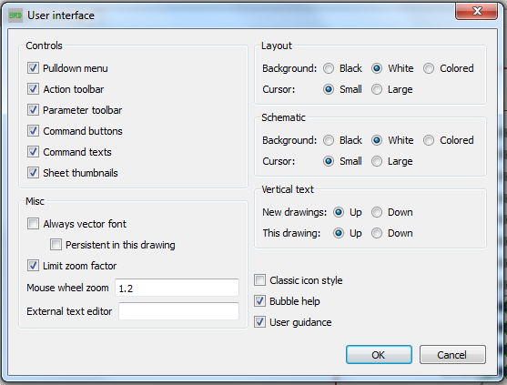

**File –Export – Image**

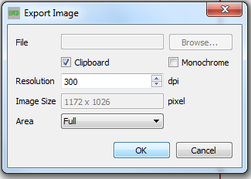

Paste the image from the clipboard and open it in Paint. From Paint save the image with a jpeg extension for printing.